IST370

Lab 10

Theme: Multiple-Row Functions (35 points)

1. Determine the number of books in each categories, along with the average retail price of the books in each category. Sort the output in ascending order of category.

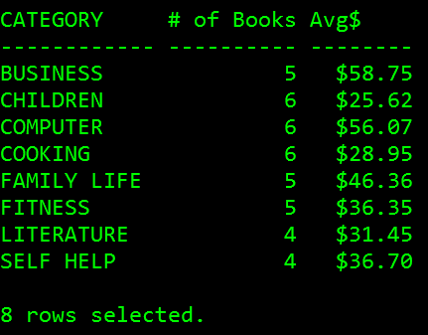

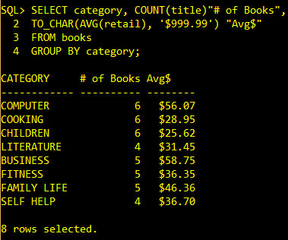

SELECT category, COUNT(title)"# of Books",

TO_CHAR(AVG(retail), '$999.99') "Avg$"

FROM books

GROUP BY category;

2. a) Determine the number of placed orders for each customer, along with the number of shipped orders for each customer. **It is required that those customers who did not place any order should also be listed in the result (such as C1002)**.

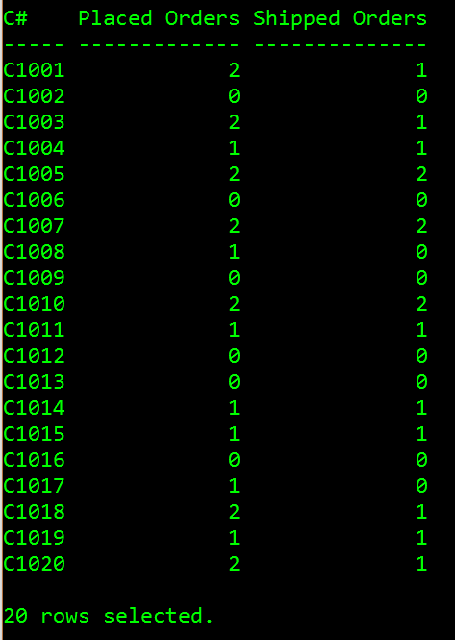

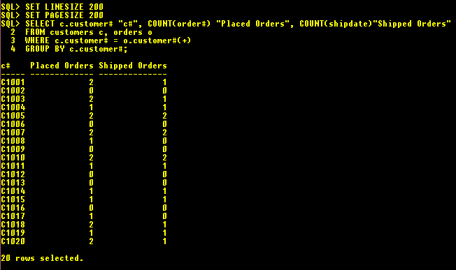

SELECT c.customer# "c#", COUNT(order#) "Placed Orders", COUNT(shipdate)"Shipped Orders"

FROM customers c, orders o

WHERE c.customer# = o.customer#(+)

GROUP BY c.customer#;

b) Determine the number of orders that have not been shipped for each customer.

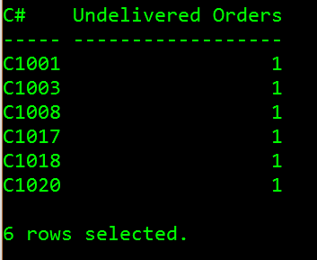

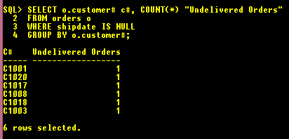

SELECT o.customer# c#, COUNT(*) "Undelivered Orders"

FROM orders o

WHERE shipdate IS NULL

GROUP BY o.customer#;

3. Figure out the purchase frequency of each book (number of times of purchase). Sort the result in ascending of purchase frequency.

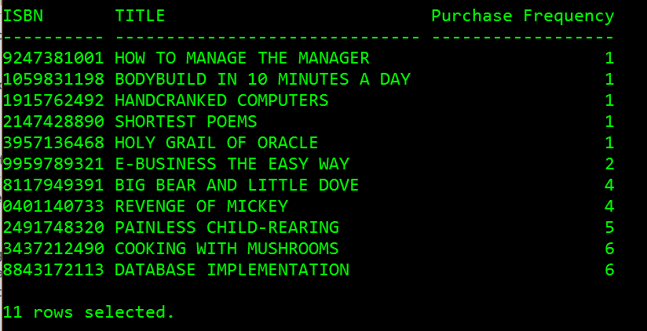

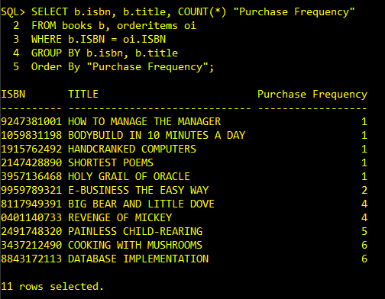

SELECT b.isbn, b.title, COUNT(*) "Purchase Frequency"

FROM books b, orderitems oi

WHERE b.ISBN = oi.ISBN

GROUP BY b.isbn, b.title

Order By "Purchase Frequency";

4. Create a query that performs the following tasks:

* Figuring out the **most expensive** (most$) and **least expensive** (least$) books purchased by each of the customers living in **Florida**.
* Computing the **average retail price** (average$) of the books bought by each of those customers (who live in Florida).
* Computing the **total profit** generated from each of those customers (residing in Florida), where the profit of each order line equals **(retail – cost)*quantity.**
* Restricting the search for only those rows with **a total profit great than $100**.
* Sorting the result in ascending order total profit.

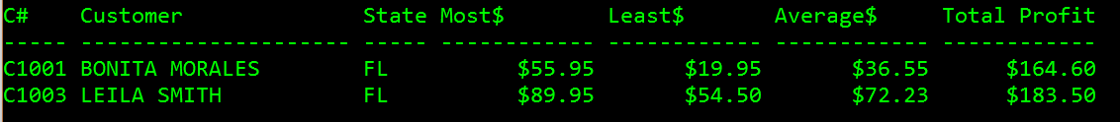

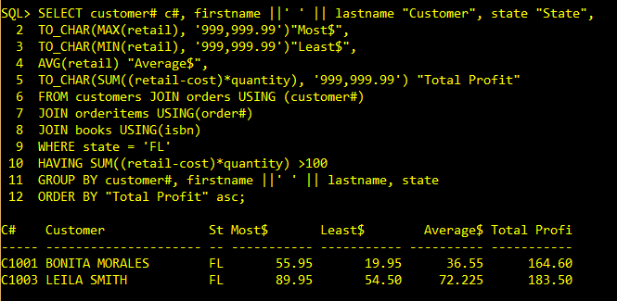

SELECT customer# c#, firstname ||' ' || lastname "Customer", state "State",

TO_CHAR(MAX(retail), '999,999.99')"Most$",

TO_CHAR(MIN(retail), '999,999.99')"Least$",

AVG(retail) "Average$",

TO_CHAR(SUM((retail-cost)*quantity), '999,999.99') "Total Profit"

FROM customers JOIN orders USING (customer#)

JOIN orderitems USING(order#)

JOIN books USING(isbn)

WHERE state = 'FL'

HAVING SUM((retail-cost)*quantity) >100

GROUP BY customer#, firstname ||' ' || lastname, state

ORDER BY "Total Profit" asc;

5. Determine the **average total profit** generated from all of the orders in the ORDERS table. (Hint: The total profit by order must be calculated before finding the average total profit.) You need to round the figure to the nearest hundredth.

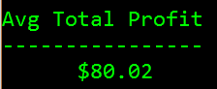

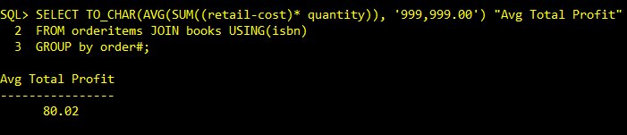

COLUMN "Avg Total Profit" FORMAT A16

SELECT TO_CHAR(AVG(SUM((retail-cost)* quantity)), '999,999.00') "Avg Total Profit"

FROM orderitems JOIN books USING(isbn)

GROUP by order#;